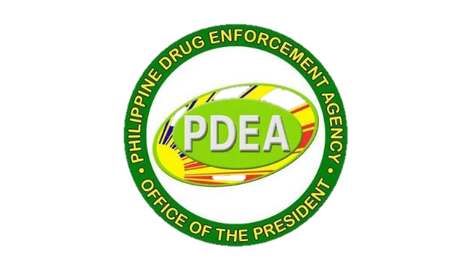

**APPLICATION FOR RETENTION OF DRUG CLEARED STATUS**



**BARANGAY MIALEN, CLARIN MISAMIS OCCIDENTAL**

**TABLE OF CONTENTS**

* Application Letter for RDCS signed by A

BADAC Chairman addressed to

ROCBDC Chairman

* Certification of No Active Drug B

Personalities (CNADP)

* Implementation of Intervention C

pursuant to MC No. 2020-041





Application Letter signed by BADAC Chairman addressed to ROCBDC Chairman

**REPUBLIC OF THE PHILIPPINES**

**PROVINCE OF MISAMIS OCCIDENTAL**

**MUNICIPALITY OF CLARIN**

**BARANGAY MIALEN**

February 12, 2024

**DIR III JIGGER B MONTALLANA**

Chairman, ROCBDC

Sir:

Good day!

The undersigned respectfully submits all necessary requirements for the application for Retention of drug Cleared Status of Barangay Mialen, Clarin, Misamis Occidental for your perusal and favorable consideration.

Respectfully yours,

**REY M. EBARLE**

Punong Barangay



Certificationof No Active Drug Personality (CNADP)



Implementation of Intervention pursuant to MC No. 2020-041